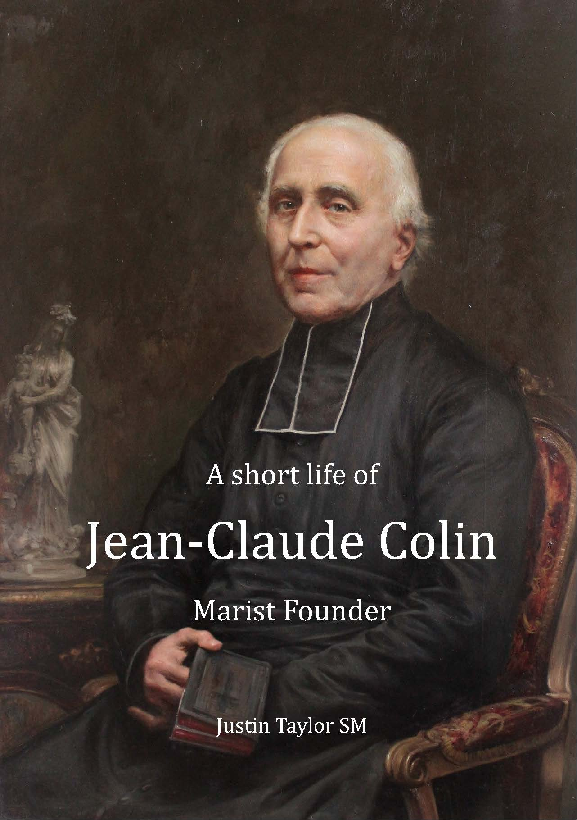
A Short Life of Jean-Claude Colin,
Marist Founder
by Father Justin Taylor, S.M.

This short life of Jean-Claude Colin is abridged and adapted from the author’s full biography, Jean-Claude Colin, Reluctant Founder (Hindmarsh, SA: ATF Press, 2018). Readers who wish to have more information about the life of Jean-Claude Colin or about the sources used should consult the full biography.

With these words, this new publication is introduced to the Marist world for pre-publication orders.

This inspiring, easily read work on the Marist founder is approximately 125 pages long. It will inform young people (secondary school or higher), lay and religious of the Marist’s founding years. If orders are placed before 15th March 2021, the cost will be for shipping.

To place your order, please send the following information to Secretariat@maristsm.org.

Minimum order is 10 (combination of various languages) to single address.
Order Form  To: Secretariat@maristsm.org  Before 15th March 2021 |  | Number of Copies
 |  | English | Français | Espagnol
Attention:
Shipping
Address:
Email:
Telephone:

