Familia M Eng 148
A Marist community served the Church in Japan for 64 years, from 1949 until 1973, mainly in the Nara and Mie areas of Kyoto diocese. The dream of sharing the Good News among the Japanese began in the Changi concentration camp during World War 2 when Lionel Marsden, an Australian Marist and military chaplain, was among the many prisoners-of-war suffering at the hands of the Japanese. He answered the call of the bishop of Kyoto and with two other Australian confreres, arrived in 1949 to begin language studies. The Nara area in southern Kyoto was entrusted to the Marists. Still reeling from the shock of the Atom bomb and the shame of defeat in the war, many Japanese flocked to the Church in search of spiritual support and meaning for their lives.
I arrived in 1969 when Japan had risen from the ashes of defeat in WW2, the wave of interest in becoming Christian had faded out, Japan had hosted the 1964 Olympics with great success and was now recognized as a growing economic power. Christianity and religion were respected and tolerated but often regarded as western imports. After two years of language study, my first appointment was Nara City parish. Parish councils were already in place throughout the diocese, the spirit of Vatican 2 was evident everywhere and the formation of laity was our number one priority so that our small Catholic communities could carry out their mission to live and share the Good News while remaining at the same time rooted in their Japanese culture. “Sowing the seed”, even without any results, is an important element in mission, but we gradually learned also to recognize the signs of “harvest” already there, because of the presence of the Holy Spirit in all that is good and beautiful in Japanese religions and culture.
I spent many happy years in Nara and other parishes, engaged especially in ministry with families, couples (“Encuentro Conjugal”), teenagers and young adults. In the early 1990’s migrants from Peru and Brazil, mostly descendants of Japanese who had emigrated at the beginning of the 20th century, began to arrive in large numbers. The Church was foremost in welcoming the migrants and the bishops produced a fine document proclaiming: “No none is a stranger in the parish”. Migrant ministry occupied much of my time in the final 20 years of my time in Japan and it was a joy to see how warmly the Japanese Catholics welcomed the new arrivals. Many have since become stalwart pillars of the Christian community and given a new face to the local Church.
In 2013, due to aging in the community and the dwindling number of Marists everywhere, it became impossible to maintain community life and we closed the mission. After 44 years in the East, I returned to the West and was appointed to Toulon. Marist presence lives on in the hearts and lives of many of the friends we left behind. Paddy O’Hare Toulon 28 June 2021

District of Asia. Vocations.
The Society of Mary- District of Asia has a vocation promotion program since the time the district decided to recruit possible candidates to become future Marists.
1. Highlights
Most of the Marists priests are fruits of this Vocation Promotion program. There are 2 components in this program.
  - MARIST INTERSTED COLLEGE STUDENTS- This is for high school graduates- 16-18 years of age. The vocation director would promote vocation to schools and parishes for the whole year round. The target candidates are graduating high school students. Those who would like to join the Society of Mary will be given an entrance exam. If they pass the exam, interview follows. If the candidate is certain to join, the vocation director or one of the Marist priests available will visit the family to meet and explain the program. They will begin their initial formation at St. Peter Chanel Formation Community while completing their Bachelor of Arts in Philosophy.
  - 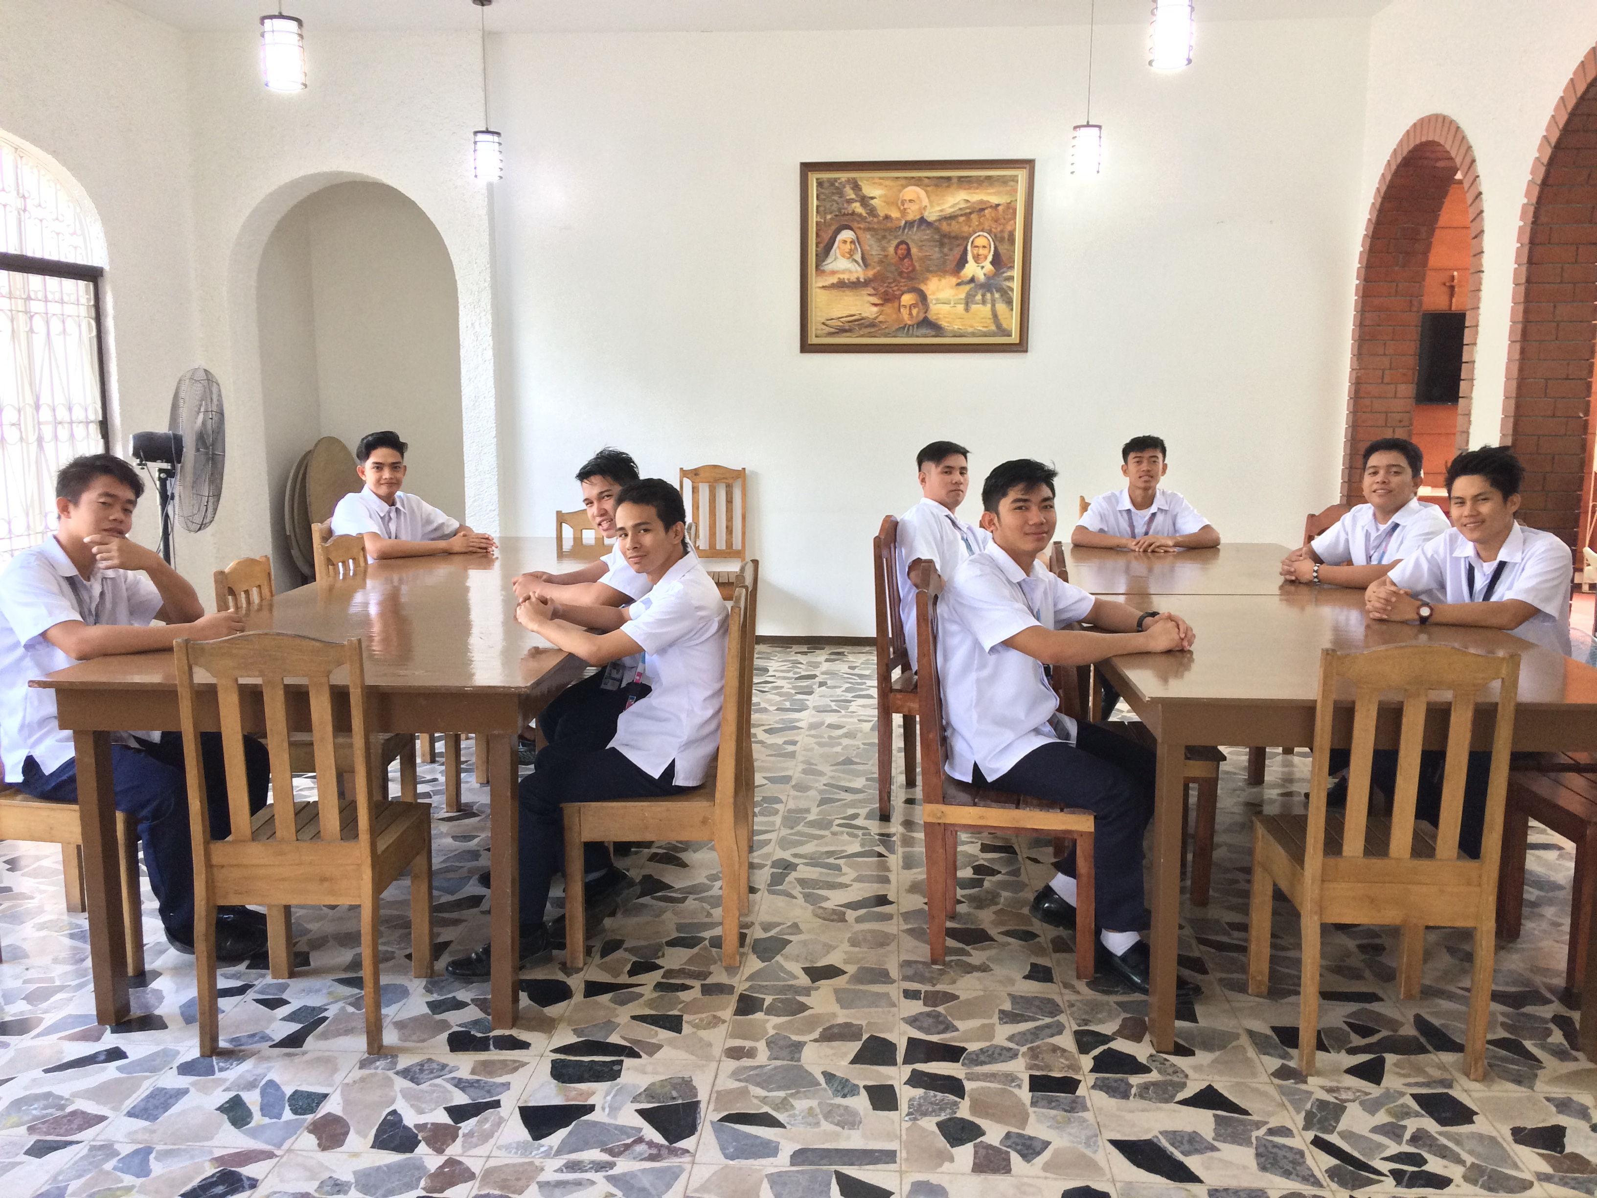

1.2. MARIST INTERESTED GRADUATE STUDENTS- This is for young professionals not beyond 32 years old. We offer vocation accompaniment for young professionals. This is to help them venture into serious discernment. He will be given opportunities to visit Marist communities and ministries. This will take at least six months. At the end, the person has to decide if his discernment will lead him to join the Society of Mary. The vocation director will give a thorough report to the council of the District about the desire of the candidate. If the candidate will be accepted, then he will start his formation. While living in the formation, he will study at least 2 years of Philosophy which is needed for theological studies in the future.

2. RESPONSIBLE PERSONS IN VOCATION PROMOTION
-The main in-charge for the promotion is the Vocation Director who is a Marist priest. He works with lay Marists vocation promoters which are mainly former seminarians and lay Marists. He links with other vocation directors especially within Marist Family.
3. Challenges
The pandemic COVID 19 has brought challenges to the promotion of vocation. Schools are closed and travels are limited. But it also opens new opportunities for creativity. The social media like Facebook has helped a lot in the disseminations of information about the Society of Mary. There have been positive feedbacks and some inquiries through our Facebook account during this time of pandemic. Vocation promotion is not a single action by the Vocation Director. It is the work of every Marist especially in fostering vocation to young people in different ministries and engagements. What is the best promotion? It starts from loving and living our vocation with the joy brought by the Gospel of Jesus Christ.

- Vocation Program – “Unity in Diversity”
The Province of Oceania consists of 9 Sectors:
i. Fiji
ii. Bougainville
iii. New Caledonia
iv. Papua New Guinea
v. Samoa
vi. Solomon
vii. Tonga
viii. Vanuatu
ix. Wallis et Futuna.
Each Sector has its own Vocation promotor, vocation team, and a vocation program.
Oceania has a Provincial Vocation Promotor who work closely with the Sectors’ Vocation Promotors.
The Provincial Vocation Promoter is Fr Justin Ratsi sm, for future communication:
E-mail: ratsijustin3515@gmail.com Mob: (679) 7215990
A Province-wide vocation promotion program is currently being drafted to mark the SM Year of Vocation. This is an effort to unify the various programs available in the Sectors and taking into consideration the cultural diversities. For traditionally, each sector has its own vocation program following the guidelines from the Province’s Formation Directory and the continuous resourcing support of the Provincial’s administration. This collaboration was effective when the Sectors are visited by the administration but since the Covid-19 pandemic the visit was done virtually.
However, despite the diversity in each Sector’s promotion and programs, as seen in examples from the Sectors below, they do follow a unity in the structure and the process:
I. Promotion
II. Invitation
III. Application to “Come and See.”
IV. Program & Accompaniment
V. Recommendation
VI. Application to Postulancy & SM formation
Apart from one Sector where the Marist Laity is involved in the Vocation promotion, the Province-wide vocation program will endeavour to develop the involvement of the Marist laity.

- Examples of Vocation programs in the Sectors

2.1 Tonga Sector
The picture below shows a Come and see program held during the weekend. From this group, 2 have been recommended to enter the Propaedeutic term to begin in August 2021. They have applied already.
Vocation promotion is done through the Tongan Catholic monthly paper, and in collaboration with other Congregations and the Diocese. The use of social media especially Facebook and Messenger are also utilized for vocation promotion is also utilized.
When applicants are accepted they are accompanied through a come and see program that is held during scheduled weekends. Of the group in the picture, 4 of them are come and see candidates. The program is supported by all the confreres in the Sector.

2.2 Solomon Sector
The Solomon sector has 4 men who have indicated their interest in the Marist Come and See. The first program is to bring in the candidates to the community to be introduced to the life of the community and getting to know them better. Afterwards the community will recommend to the Sector Delegate and his council those that are fit to enter to the Come and See program. The program is run in preparation to apply for the Propaedeutic term at the Pacific Regional Seminary.

2.3 Bougainville Sector
This sector runs its promotion through individual contacts and vocation awareness programs in parishes. Currently there are 5 candidates as seen in the picture below while they were sitting their English examinations for acceptance to formation. Part of the vocation promotion is a planned tour of the island.
A vocation team of 3 priests plan the come and see program and then follow through with them. Other confreres are also invited to offer their expertise in allocated times.

2.4 Fiji Sector
The Sector Fiji has benefitted a lot from the presence of the Marist in the Sector. Marists are involved in four parishes, a College, A Rural Training Centre, and Marist house of Formation (Marist college). The Provincial administration house is also in Fiji. The seminarians, brothers and Priests go out to the villages for vocation promotion. The laity are also involved in the vocation promotion too. Fiji has 5 candidates who are currently preparing to enter the Propaedeutic term in August.
The picture shows the formation community at Marist College where 19 students are currently in formation. There are 4 students doing their Marist Mission Experience year and one student, due to Covid-19 travel restriction had to begin his formation and studies in the Bomana seminary in Ports Moresby.
A further 2 students are completing their studies from the International Theologate in Rome. So, altogether, we have 22 men in formation.

Rest of the Sectors.
They are following in the same directions and are continuing to attract vocation to the Society of Mary.

Summer Pastoral Experience Marist Virgen Peregrina Community - Sahagún, Spain

As the academic year ended, plans were beginning to be made about where to go and what to do over the summer holiday. In ‘Casa di Maria’, the students of year one have no holidays, and they are expected to go to different places over the summer for pastoral and community experiences. With the pandemic and visa restrictions to most countries, we had limited options. However, I was allowed to travel to Spain to our Marist community in Sahagún.
Sahagún is a town and a municipality located in the Eastern province of Leon and part of the autonomous community of Castile and León. The Marist community is located on the Way to Compostela. The community runs a hostel for pilgrims in a Benedictine Nuns Monastery, they serve the spiritual, moral, and psychological needs of pilgrims on the ‘El Camino di Santiago’ or in English, the Way of Saint James.
The main objective of the Marist ministry in this community is to be ‘Mary’s presence in the world’. This Marian vision is shared by all Marists and lived and expressed in various ways taking into consideration the cultural dynamics of the places in which they find themselves. Their work in the ‘Albergue Santa Cruz’, consists of welcoming each pilgrim as if it was Christ himself (cf. Mt 25:35-40). This Marist approach to ministry brings peace and joy to pilgrims who stop by at the Albergue. This has been testified to through the feedback from pilgrims on the social media page of the Albergue and the guest book at the reception. The work is done for the glory of God and honour of the Blessed Virgin Mary. As part of my integration into the life and ministry of the community, I was invited to have an experience of walking some of the Camino.
So, on Wednesday 14 July 2021, after experiencing the work in the hostel and meeting different pilgrims from different places around the world, Fr Daniel drove me about 75km to a town called Frómista where I began a pilgrimage for one week to the city of Astorga covering about 168km. I was excited to have an experience of this pilgrimage that many people and especially Christians have stridden over the centuries. Though excited, I was a bit afraid as many questions came to my mind which I did not try to give answers to so as not to discourage myself so I could just be there, living the moment.
The reason for this pilgrimage was to have an idea of what the pilgrims who come to the hostel live and experience on the way and at the same time, I wanted to make this experiences my own by experiencing the pains, the loneliness, the solitude, the sunburns, the cold, the snoring at night when sharing Albergues with other pilgrims, the pilgrims’ meals, the heavy backpack, the long stretch of roads with no houses or bars, etc.
In all these physical and moral challenges, lies hidden what many calls ‘the Camino magic’. Indeed, there is something beautiful and sometimes obscure about the Camino. Though taking up this challenge without having adequate preparation, I believe this experience has left something deep within me. Each time I reflect alone on my experience and listen to others share their experiences; I receive a new insight from my experience.
On the spiritual side of my experience on the Camino, God was always and truly present. I had so many instances where I was physically alone, aware of the movements within me and listening to nothing else outside except my footsteps and feeling the water bottle that was hanging around my neck. This gave me time to reflect on many different aspects of my life. I went about this by asking so many questions about my life, looking at my past, present, and future. The three questions that were at the base of my reflections were: what does God want of me? What do I want of myself? And where am I going to? These questions still remain with me as I continue my own life’s journey, a journey towards knowing God’s will for my life and all that I am called to do.
It has been a blessing sharing Marist life in Sahagún and meeting pilgrims and listening to their stories. One captivating aspect of my experience is the honesty and depth of the experiences we shared every day at 5 pm during the pilgrims’ coffee. Often, the most important thing to know is why we are on a journey. However, it is not enough to stop there. Perhaps it is important to know where the journey is leading us. Therefore, we must focus on both the goal and the journey, and this entails finding the right balance. Daniel Smith said, “live a life that is well balanced; don’t do things in excess.” Finding this balance in ordinary life is not always easy.
The Camino and its magic allows each one to be more aware of who we are, the things around us, perhaps it is the things around us that in many ways lead to a better awareness of ourselves. Always fixing an eye on the Camino arrows is itself a way of finding a balance and staying on track. In the end, whether you like it or not, there is metanoia, a change both physical and spiritual. Since life itself is a journey, we must not have to wait for a Camino to find a change or a balance in our lives. Make your life a Camino and a Camino your life.
There is a parallel or a metaphor between our ordinary life and the experiences on a Camino. On the Camino, we are conscious of movements, and we can see it because we are taking one step at a time. It is important for anyone who has done the Camino not to simply return to the ordinary life once the Camino is over but to bring the experiences of the Camino back into ordinary life. The learnings, the questions and the responses during the Camino can help us to enrich and embrace our everyday life taking everything a step at a time. The strong sense of family, sharing, caring for one another on the way, the communication, the physical, moral, spiritual, and psychological supports, the simple lifestyle, the attention to tiny things, the appreciation of nature… must remain with us and be shared with those who have not had any experience of the Camino. It is a call, and my wish is that my life should be a Camino and my Camino should be my life.
In addition, as part of my program and life as a religious, I applied to my district superior to renew my vows as a Marist, my application was accepted, and I was called to renew my vows. This had to be done while I was on my pastoral experience at Sahagún. So, on Thursday 19 August 2021, Fr José Antonio Fernández was delegated to receive my vows. This took place in a beautiful and simple Eucharistic celebration in the chapel of the Albergue in the Monastery. Present were our Marists fathers from León and a lay Marist volunteering at the Albergue. In his homily, Fr José Antonio reminded me of the importance of the vows I am renewing. Referring to the Pledge of our Marist Pioneers in the Cathedral of Fourvière on 23 July 1816, he quoted, “We solemnly promise that we shall spend ourselves and all we have in saving souls in every way”. The ‘every way’ were the words that he went on to develop.
He then took some key texts from our Constitutions and concluded by saying, “you are renewing your vows in the course of your formation. And the formation that you are undertaking does not have to look at what the Marists of today have done in the past or are doing now, but towards what the Marists of tomorrow must do. To be faithful to the spirit of the society of Mary, the Marist of tomorrow must examine the present and the future, to discover what are the urgent needs of the men and women of our time in the places where we live our apostolic Marist vocation”. The day ended with a simple meal and chatting.
By way of conclusion, I am grateful to all the Marist laity, priests, and brother of the communities of León and Sahagún for the love and community life we shared. To all the pilgrims who passed by during my time at Sahagún, you have all left a mark in my life. We have all offered one another something and sometimes unable to name it. May the experiences we have shared for the last two months continue to bear fruit in our lives that will remain accessible to all who are in need. May the love of God and spirit of our Blessed Mother Mary in her icon as Our Lady of the Way, continue to intercede for us on our earthly pilgrimage.
Clinton Asunkwain KUBE, sm

