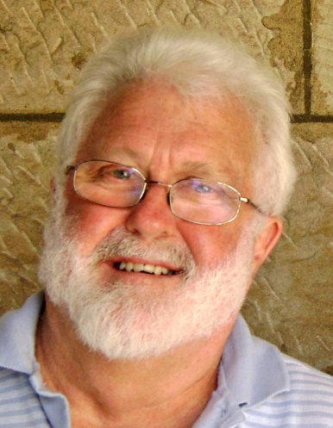
REFLECTION AFTER THE FIRES, UNFINISHED BUSINESS
We’re not likely to forget this summer any time soon. The widespread damage caused by the bushfires to the environment, to wildlife and to so many families has made an indelible impact on us. Even as fires still burn, recovery is underway, supported by governments and by the generosity of thousands of Australians.
The effects of the fires, compounded by the ongoing drought, will be with us for years to come.
The drought, bushfires and searing heat have caused us to sharpen our focus on the issue of climate change and the degree to which human activity is responsible.
Questions around climate change will continue to occupy us and will require strong and decisive leadership from government as well as the careful use of resources by each one of us.
When the last of the bushfires have been extinguished, we will still be left with the questions about what kind of world we will leave for our children and grandchildren. Each one of us has a part to play in responding to these questions.
On another front, when we reflect on our treatment of each other we will realise that we have unfinished business that needs addressing. Latent racism doesn’t need much encouragement to bubble to the surface.
The concerns about the coronavirus have seen Chinese members of our community being subjected to innuendo and downright abuse. Mindless fear has no trouble finding easy targets.
Another Australia Day has been and gone and in many public events on the day, the cultures of our First Nations people featured. Perhaps well-meaning, healing and consciousness-raising, this may also have occasioned pain among some who considered these events to be window-dressing while the big questions of recognition still wait to be addressed.
The Uluru Statement from the Heart in 2017 was presented to the Australian community after extensive consultation and reflection. Its key recommendations were quickly brushed aside by the Turnbull/Joyce government as being unworkable.
The process of real reconciliation with the many nations of our First Peoples is going to require long, painstaking and respectful listening. A variety of commentators agree that these matters need to be resolved before any progress towards an Australian Republic can claim any traction. The maturing and healing of our human environment is something in which each of us can play a part.
These are just a few items of unfinished business that confront us as we start to emerge from this summer of drought and fire.
At the end of the great creation story in Genesis, God entrusts the world and all its creatures into our care. We are to be stewards rather than conquerors, carers rather than consumers, co-creators rather than exploiters.
By any measure, we have failed to honour the trust God has placed in us and so we face the prospect of a world struggling to breathe.
As we move into the journey of this year, we do so in company with many others who are aware of the unfinished business that calls for our attention and action.
We hear the voices of the young whose future well-being depends substantially on our response. We hear the challenging encouragement of Pope Francis who keeps reiterating his belief that we are capable of greatness as we seek a way forward in these difficult times. We listen to the findings of the scientists who alert us to the urgency of the tasks at hand.
We hear too the voice of Jesus whose purpose was universal well-being, the salvation of all, and so those open arms on the Cross prompt St Paul to declare that Jesus is “the first-born of all creation.” (Colossians 1,15)
Nothing is beyond the reach of God’s saving purpose. Nothing therefore, need be beyond the reach of our concern, care and action.
May something of our unfinished business inspire each one of us to bring forward something of God’s saving purpose as we move on from here.
Father Kevin
Feb 9, 2020

