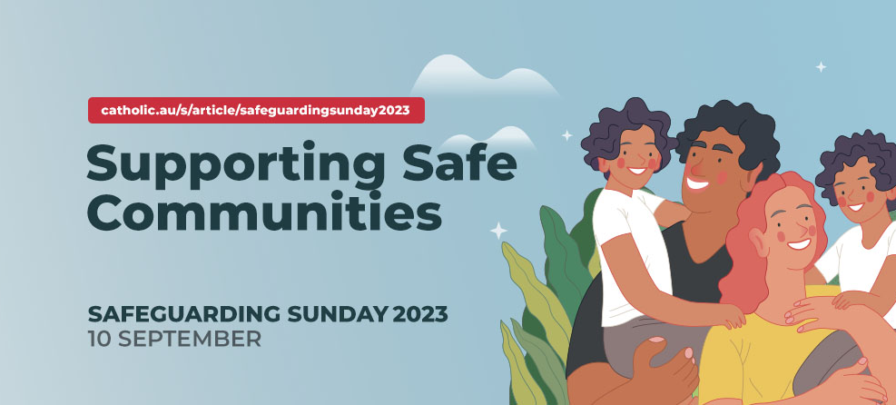

Prayer
Gracious God,
you love and care for all of your children,
especially the smallest and most vulnerable.
We entrust to you the lives of children and adults at risk
who have been abused, neglected or exploited
and whose trust and innocence have been destroyed.

Help us to hear their cries of pain
and to take responsibility for those whose lives have been broken.
Help us to recognise the hurt felt by those wounded by abuse,
and the failure to be heard.

We pray that with the help of your grace
communities and families will find understanding and support,
so that now and in the future
their wounds may be healed
and they may find lasting peace.

Let your grace and love fall gently now upon our children and adults at risk,
giving them the inner strength, peace and resilience
to seek out assistance when required.

We ask this prayer through our Lord Jesus Christ, your Son,
who lives and reigns with you
in the unity of the Holy Spirit, God forever and ever.
Amen

